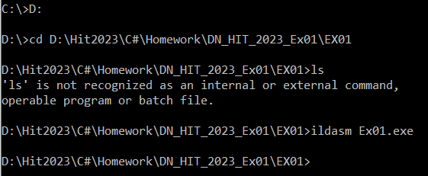
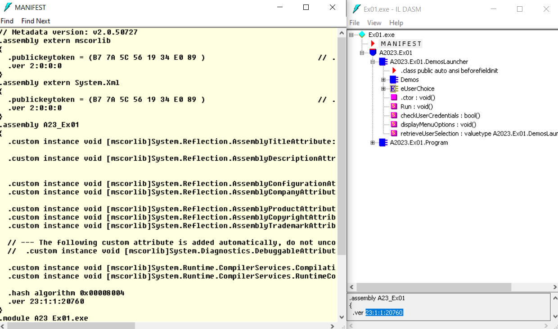
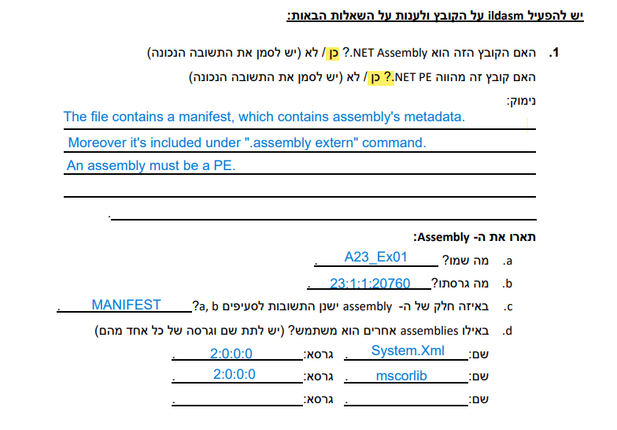
.2
Type (Struct/Class/Enum) | Name | Members (methods, fields)
class | A2023.Ex01.DemosLancher | class public:  *class Demos  *class enum  methods:  *public constructor :void()  *public static Run: void()  *private static checkUserCredentials : bool()  *private static displayMenuOptions: void()  *private static retrieveUserSelection : valutype eUserChoice()
class | Demos | class nested public: methods:  *public .ctor: void()  *public static RunBinaryInput: void()  *public Static RunSandMachineProgram: void()  *private static buildLine: int(StringBuilder, int int)  *private static bool checkIfAscendingSeries(string)  *private static bool checkIfDescendingSeries(string)  *private static void drawSandMachine(int)  *private static string getInputFromUser([out] int)
Enum | eUserChoice | class enum nested private:  *field public static BinaryInput=int32  *field public static Exit = int32  *field public static SandMachine = int32  *field public value__ = int32
class | A2023.Ex01.Program | class public: methods:  *public .ctor : void()  *method public static void Main()

Found the Username and Password in checkUserCredentials : bool()
Username: C-Sharp
Password: HIT23A
